***FiLDI Outcomes***

***World Bank Evaluation of CEC Model***

The Change Management Workshop conducted by the CEC for officials of World Bank Funded Project were evaluated by external evaluators   
Dr. Kurian Baby, PhD, (International Research Congress),Dr.A J James, PhD, Sowmya Kapoor appointed by the World Bank. The concluding reflections of the report say “*The Change Management programme under the IAMWARM project is a unique experiment that has been able to successfully deliver on project outcomes by helping officials overcome departmental boundaries and innovate for change. The experience with the CM programme holds significance because it demonstrates that, for departments to work together and work better for the communities they serve, there needs to be a shift in behavioural norms that define the relationships between officials, between departments, between ranks, and with the public that these officials serve. Unless these norms change, it is extremely difficult to affect collaboration on the ground, and with communities. This becomes doubly important given a context of the bureaucratic labyrinth that defines India”.*

***9.2 Community level Impact of Change Management Training for IAMWARM Project Officials - By Institute for Sustainable Development, Chennai***

The Change Management (CM) training offered to the officials of the constituent State Government Departments of Tamil Nadu Irrigated Agriculture Modernization and Water-bodies Restoration and Management (TN IAMWARM) Project aimed at establishing an enabling environment and sustained demand for change through dialogue, public consultations, and capacity-building at all levels of government. The World Bank supported Change Management Training at a micro level to officials working in 20 villages during 2011 and, based on the success of the experiment, decided to scale it up to the medium-level in 2014. This report is the assessment of the impact of training, as experienced by the community.

**Key Findings**

The treatment area and the control area differ significantly in terms of the behaviour of officials: Officials who received the specialized Change Management Training (CMT) were perceived by the community as having different attitudes and behaviour compared to officials whohad no such training. Specifically, villagers felt that officials specialized with CMT.

1. Visit more frequently
2. Visit more often with officials from other participating/converging departments
3. Visit more often whenever there is a need
4. Meet more stakeholders including small and marginal farmers
5. Meet all beneficiaries
6. Discussed project interventions and gave information on various relevant issues such as farming, water management or overall development of the village
7. Answered villagers’ queries
8. 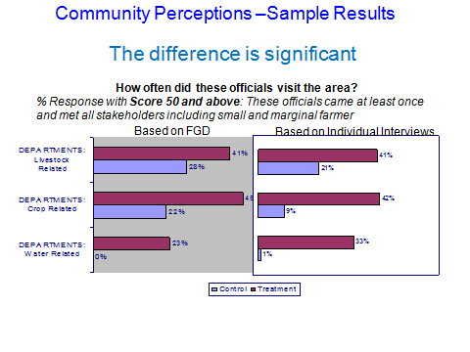Listened to villagers’ suggestions

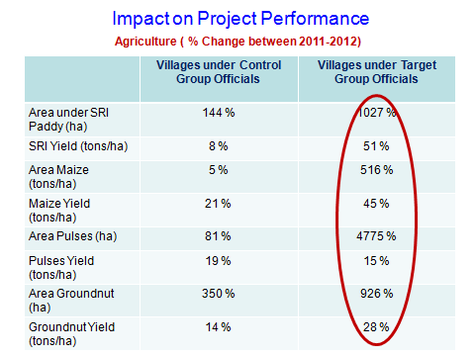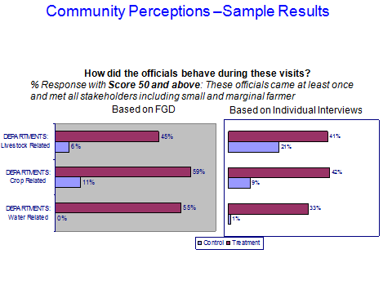

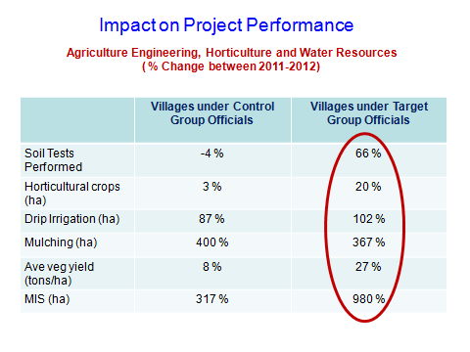

***Values Shift amongst officials of Eight Departments under IAMWARM Project***

A study of the shift in values amongst officials across eight departments (all of which followed the Change Agents Networks (CAN) model in Tamil Nadu) by the evaluators reported to the World Bank that (Values Technology California, 2012):

1. The change training did indeed create significant life-changing shifts in public officials’ perceptions. This was expressed both by individuals and by the target cohort.
2. The change programme supported officials in aligning personal values with the values of the public service as explored in the programme and in securing strong foundational values.

A similar external evaluation (Joy, 2007) done in the Tamil Nadu Rural Water Supply Program (TNRWS) in 2006 reported significant shifts in the values of engineers who had worked with the change management (CAN) model. The evaluation went on to report

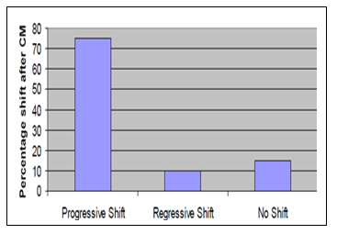

**Values shift with CAN in TN Water Utility (2007)**

*Source: Joy. L, 2006 Values Technology*

‘We conclude that, without doubt, the premises of the Change model are soundand that the programme is effective in shifting values as it is designed to do. This suggests validity for the hypotheses that change can come from within the field-level arena of the public sector to improve public service delivery by changing personal values’ (Values Technology, California, 2012).